**Organization Sign up page 2**

Step 1: Read & Agree to our Rules (below).

………..

Step 2: Fill out the Sign-Up Form.

Step 3: Read your confirmation email from Genine. We may ask for your adoption paperwork.

**Organization Sign up page 2**

* Required fields are shown in orange.
* Info in **blue boxes** will **not** be seen by the public

1. General Shelter/ Rescue Info

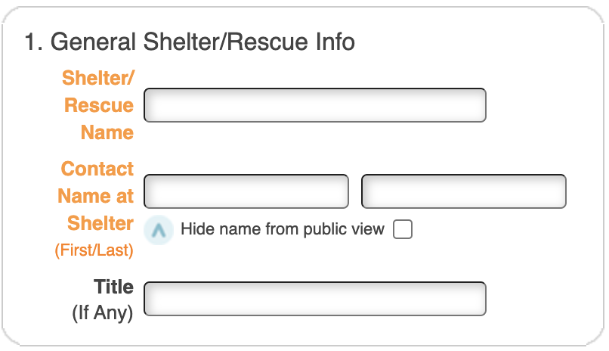

2.Address

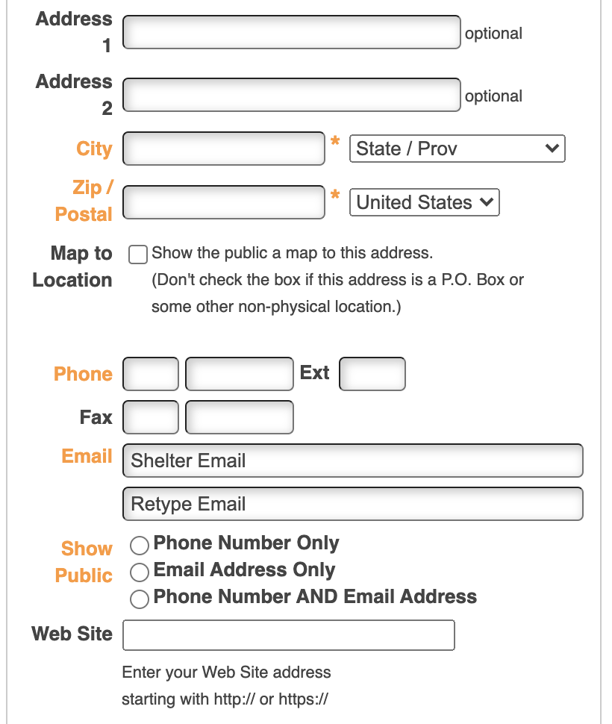

3. Login Info ( You will be able to add up to 3 users later on)

 All info same as "Main Shelter/Rescue Contact".

First/ Last Name:

Phone:

Email: (Ask for retype to confirm)

Choose a password: (Ask for retype to confirm)

4. Vet Info ( Vet info is used as a reference)

Vet name

Vet phone number: _________ Ext__

Vet email:

5. About your organization

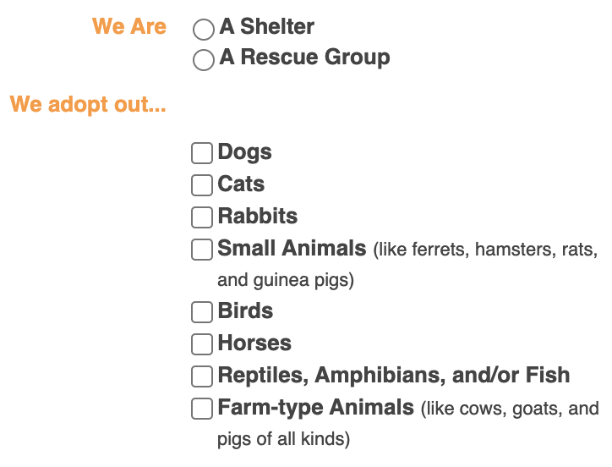

5. Con’t. Private info about your organization

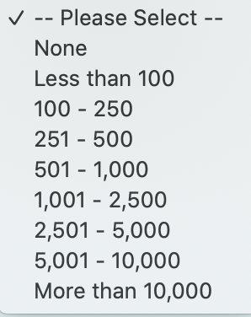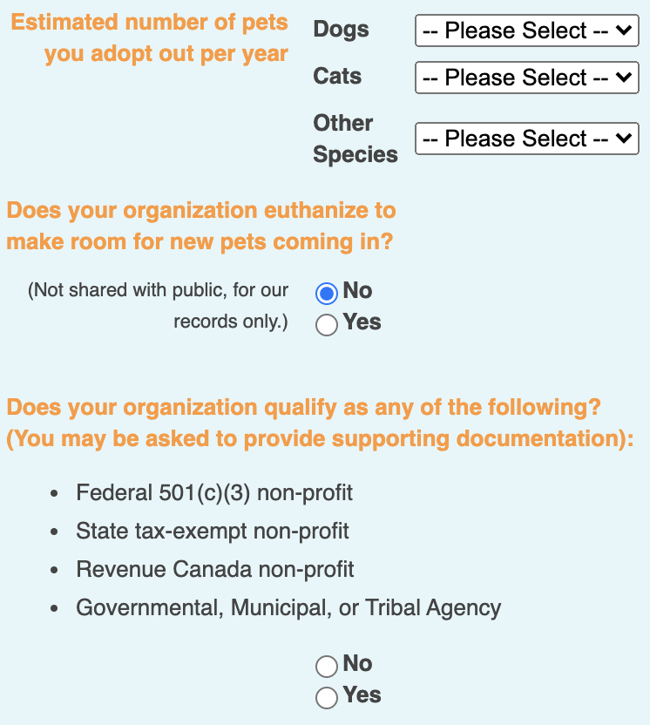

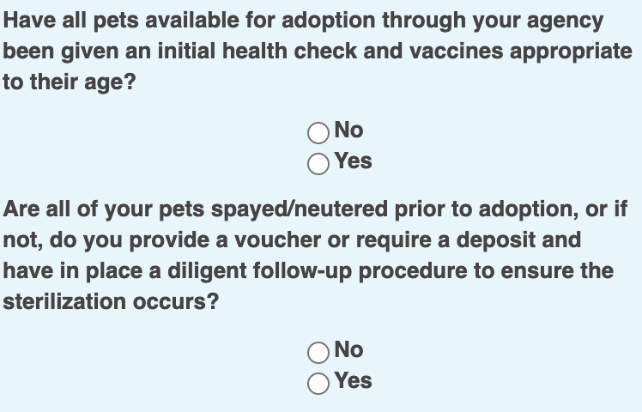

6. Area served… ( List cities, counties...etc., that you serve. This will help with our geo-located based paring )

7. Your Adoption process

Step 1

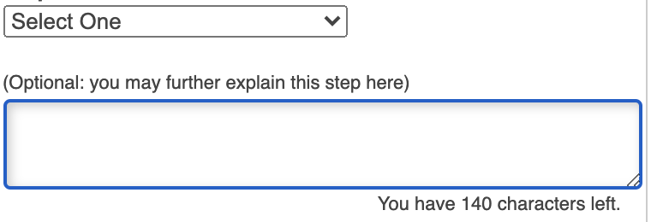

Step 2



Step 3



* Add an additional Step (Bottom)

8. About Us: (Who you are, what you do, & why you do it, etc)

9. Upload a photo or logo of your organization.